**Design Patterns**

Design patterns are reusable solutions to common problems that arise during software design and development. They provide a way to organize and structure code in a more maintainable, scalable, and efficient manner. Design patterns are not complete pieces of code or libraries, but rather high-level templates that guide how different components of a system can interact and collaborate.

To help you understand design patterns better, here are some scenarios along with corresponding design patterns that could be applied:

**Scenario: Managing Database Connections**

You are developing a web application that requires efficient and consistent management of database connections. You want to avoid creating a new database connection every time a request is made, as it can be resource intensive.

Design Pattern: Singleton

The Singleton pattern ensures that a class has only one instance and provides a global point of access to that instance. You can create a Singleton class to manage the database connection, ensuring that only one connection is maintained throughout the application's lifecycle.

**Scenario: Decoupling UI Components**

You are building a graphical user interface where different UI components need to interact with each other, but you want to avoid tight coupling to allow for future changes.

Design Pattern: Observer

The Observer pattern defines a dependency between objects, so that when one object changes state, all its dependents are notified and updated automatically. Each UI component can act as an observer, subscribing to changes in other components they're interested in.

**Scenario: Flexible Object Creation**

You are designing a system that involves creating complex objects with various configurations. Constructing these objects directly in code can become messy and hard to maintain.

Design Pattern: Builder

The Builder pattern separates the construction of a complex object from its representation, allowing the same construction process to create different representations. This is particularly useful when you have multiple ways to configure an object.

**Scenario: Adapting Interfaces**

Your application relies on a third-party library that provides data in a format that doesn't match your internal data format. You need to transform the external data into a format compatible with your application.

Design Pattern: Adapter

The Adapter pattern allows objects with incompatible interfaces to work together. You can create an adapter that acts as a bridge between the third-party library and your application, translating the data from one format to another.

**Scenario: Managing Undo/Redo Functionality**

You are developing a graphic editing application and want to provide users with the ability to undo and redo their actions in a seamless manner.

Design Pattern: Command

The Command pattern turns a request into a standalone object, containing all the information needed for its execution. Each user action in your application can be encapsulated as a command, allowing you to easily implement undo and redo functionality.

**Scenario: Handling State Transitions**

You are working on a vending machine simulation, and the behavior of the machine changes based on its current state (e.g., idle, waiting for payment, dispensing).

Design Pattern: State

The State pattern allows an object to change its behavior when its internal state changes. Each state of the vending machine can be modeled as a separate state class, which defines how the machine behaves in that state.

These scenarios and corresponding design patterns illustrate how design patterns can provide solutions to common problems in software design. By applying these patterns, you can improve the structure, maintainability, and extensibility of your codebase.

**Singleton Pattern**

The Singleton pattern is a design pattern that ensures a class has only one instance and provides a global point of access to that instance. In other words, it restricts the instantiation of a class to a single object, preventing multiple instances from being created.

**Analogy: Singleton as the President's Office**

Imagine you're running a company, and you have a special office called the "President's Office." This office should have only one occupant at a time, no matter who comes to visit. This person is the President of the company.

Creation of Office:

When you need to create the President's Office, you check if it already exists. If it doesn't exist, you create it and assign the person to be the President. If it does exist, you simply use the existing office.

Access to the Office:

Anytime someone wants to meet the President, they visit the President's Office. No matter how many people visit, they are always directed to the same office because there's only one President's Office.

In this analogy, the "President's Office" represents the instance of a class in software, and the "President" represents the single object that the class is meant to create. Just like there's only one President's Office and President in the company, the Singleton pattern ensures that there's only one instance of a particular class in the application.

In programming terms, the Singleton pattern helps guarantee that no matter how many times you try to create an instance of a class, you'll always get the same instance. This can be useful for situations where you want to ensure that there's only one point of access to a shared resource, like a configuration manager, a database connection, or a logging system, just as there's only one point of access to the President's Office in our analogy.

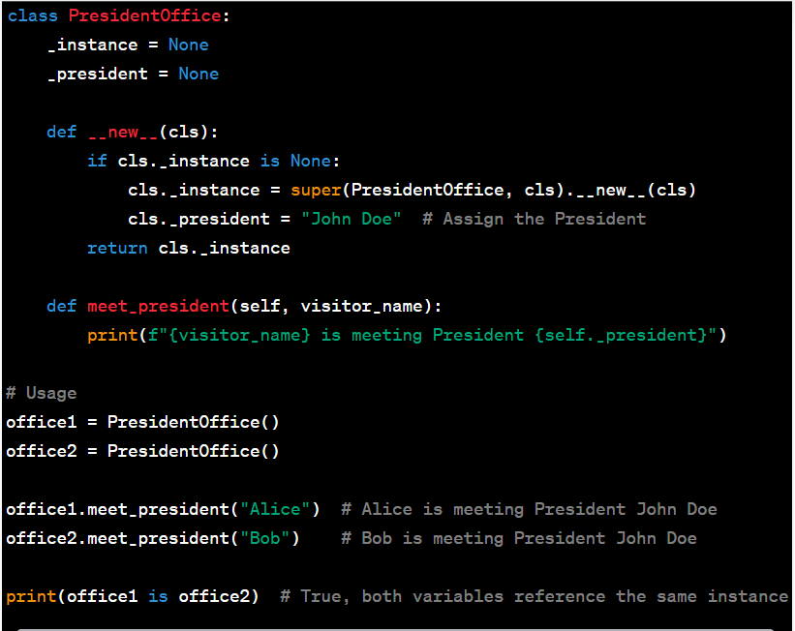

Code Explanation:

* **class PresidentOffice:**: This defines a class named **PresidentOffice** which represents the Singleton class for the President's Office.
* **_instance = None**: This is a class variable that will hold the single instance of the **PresidentOffice** class. It starts as **None**.
* **_president = None**: This is a class variable that will hold the name of the President. It starts as **None**.
* **def __new__(cls):**: This is a special method that is automatically called when an instance of the class is being created. It is responsible for controlling the creation and retrieval of instances.
* **if cls._instance is None:**: This checks if the **_instance** class variable is **None**, indicating that an instance of the class hasn't been created yet.
* **cls._instance = super(PresidentOffice, cls).__new__(cls)**: If **_instance** is **None**, this line creates a new instance of the **PresidentOffice** class using the **super()** function. It ensures that the new instance is properly initialized.
* **cls._president = "John Doe"**: If an instance is being created, this line assigns the name "John Doe" to the **_president** class variable, representing the President's name.
* **return cls._instance**: Finally, the **__new__** method returns the **_instance** variable, ensuring that subsequent calls to create instances return the same instance.
* **def meet_president(self, visitor_name):**: This is a method within the **PresidentOffice** class that takes two arguments: **self** (which refers to the instance of the class) and **visitor_name** (the name of the visitor).
* **print(f"{visitor_name} is meeting President {self._president}")**: This line prints a message indicating that a visitor is meeting the President. It uses the **_president** class variable to get the President's name.
* **office1 = PresidentOffice()**: This line creates an instance of the **PresidentOffice** class and assigns it to the variable **office1**.
* **office2 = PresidentOffice()**: Similarly, this line creates another instance of the **PresidentOffice** class and assigns it to the variable **office2**.
* **office1.meet_president("Alice")**: This line calls the **meet_president** method on the **office1** instance, indicating that "Alice" is meeting the President.
* **office2.meet_president("Bob")**: Likewise, this line calls the **meet_president** method on the **office2** instance, indicating that "Bob" is meeting the President.
* **print(office1 is office2)**: This line checks whether **office1** and **office2** reference the same instance by using the **is** operator. In this case, it prints **True**, confirming that both variables reference the same instance of the **PresidentOffice** class.

**Factory Pattern**

The Factory Pattern is a design pattern that provides an interface for creating objects in a super flexible way. It's like a "factory" that produces objects based on a set of rules and instructions. This pattern is useful when you want to create different types of objects that share a common interface or parent class, without specifying their exact class names directly.

**Analogy: Pizza Restaurant Factory**

Imagine you own a pizza restaurant. You have different types of pizzas on your menu, each with its unique set of ingredients and preparation methods. To handle the creation of these pizzas, you set up a "Pizza Factory."

Pizza Factory:

You have a dedicated area in your kitchen where you make pizzas. This is your "factory." Customers place orders for different types of pizzas.

Ordering Pizzas:

When a customer orders a pizza, they don't need to know how each pizza is made or what ingredients are used. They simply tell the waiter the type of pizza they want, like "Margherita," "Pepperoni," or "Vegetarian."

Pizza Creation:

The waiter takes the order to the pizza factory, where the chefs follow a standard procedure to create the requested pizza. They assemble the crust, sauce, cheese, and toppings according to the type of pizza ordered.

Serving the Pizza:

Once the pizza is ready, the waiter serves it to the customer. The customer gets exactly what they ordered, without needing to know the details of how each pizza was made.

In this analogy, the "Pizza Factory" is the factory in the Factory Pattern. The different types of pizzas are the objects being created. Customers placing pizza orders are analogous to the code that requests the creation of objects using the Factory Pattern. The factory encapsulates the details of object creation, allowing the code to work with a common interface (ordering pizza type) rather than directly dealing with the pizza-making process (object instantiation).

Similarly, in software development, the Factory Pattern involves creating a factory class that provides methods to create objects without exposing the instantiation logic to the client code. This promotes flexibility and helps manage object creation in a centralized way.

* **class Pizza:**: This defines an abstract base class called **Pizza**. It serves as a common interface for all types of pizzas. It includes a method named **prepare**, which is meant to be overridden by the concrete pizza classes.
* **def prepare(self):**: This defines an abstract method named **prepare** within the **Pizza** class. Abstract methods are placeholders that must be implemented by subclasses. In this case, the **prepare** method will hold the specific steps for preparing each type of pizza.
* **class MargheritaPizza(Pizza):**: This defines a concrete pizza class named **MargheritaPizza**, which inherits from the **Pizza** class. It represents a specific type of pizza.
* **def prepare(self):**: This overrides the **prepare** method from the **Pizza** base class. When an instance of **MargheritaPizza** is created and its **prepare** method is called, it prints a message indicating the preparation of a Margherita pizza.

(Repeat the above two blocks for **PepperoniPizza** and **VegetarianPizza** classes, explaining the same concepts.)

* **class PizzaFactory:**: This defines the **PizzaFactory** class responsible for creating different types of pizzas.
* **def create_pizza(self, pizza_type):**: This method takes a **pizza_type** argument and creates an instance of the corresponding pizza type based on the provided type.
* Inside the **create_pizza** method:
  + It checks the value of **pizza_type**.
  + If the type is **"Margherita"**, it returns an instance of **MargheritaPizza**.
  + If the type is **"Pepperoni"**, it returns an instance of **PepperoniPizza**.
  + If the type is **"Vegetarian"**, it returns an instance of **VegetarianPizza**.
* **factory = PizzaFactory()**: This creates an instance of the **PizzaFactory** class, which will be used to create pizza instances.
* **pizza1 = factory.create_pizza("Margherita")**: This uses the **factory** instance to create a **MargheritaPizza** instance and assigns it to **pizza1**.
* **pizza2 = factory.create_pizza("Pepperoni")**: This uses the **factory** instance to create a **PepperoniPizza** instance and assigns it to **pizza2**.
* **pizza3 = factory.create_pizza("Vegetarian")**: This uses the **factory** instance to create a **VegetarianPizza** instance and assigns it to **pizza3**.
* **pizzas = [pizza1, pizza2, pizza3]**: This creates a list called **pizzas** containing the created pizza instances.
* **for pizza in pizzas:** This starts a loop to iterate through each pizza instance in the **pizzas** list.
* **pizza.prepare()**: This calls the **prepare** method on each pizza instance, leading to the printed messages about pizza preparation based on their respective types.

This code demonstrates the Factory Pattern by creating different types of pizzas using a factory class, encapsulating the creation logic, and promoting flexibility in object creation.